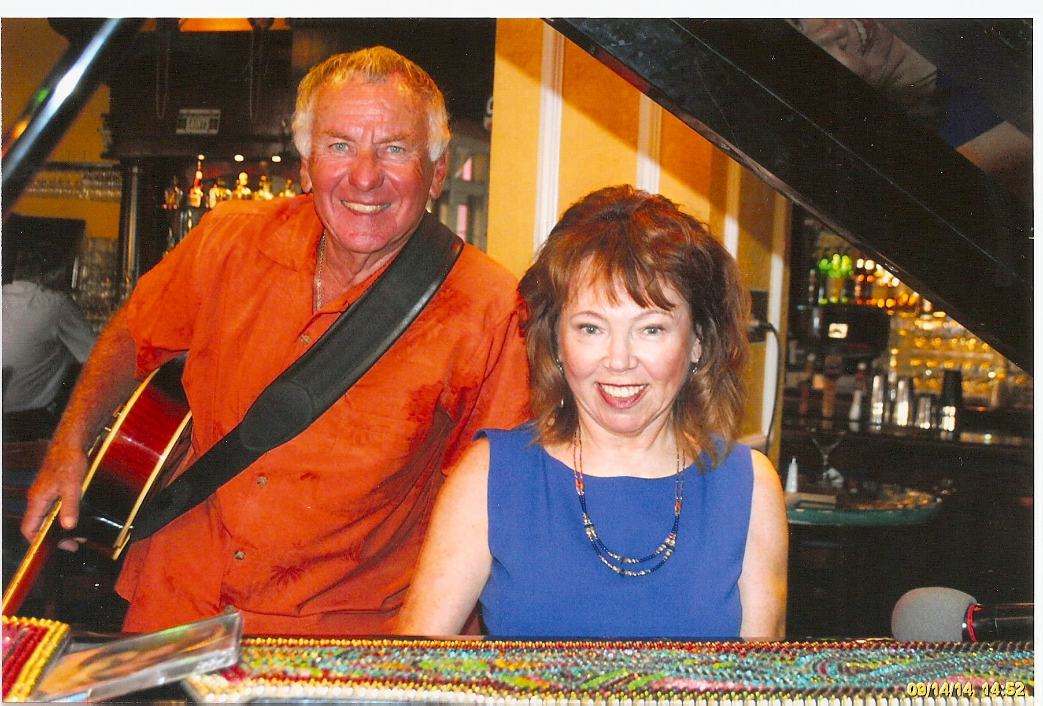

Contact:

**Barbara Reed:**

Ph: 562-843-1770

[www.BarbaraReed.org](http://www.BarbaraReed.org)

[musicwrite@charter.net](mailto:musicwrite@charter.net)

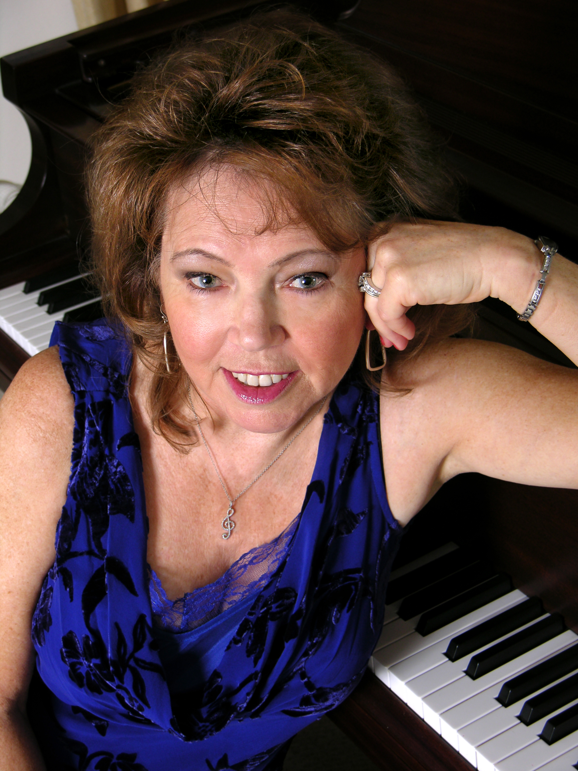

***Don’t miss . . .***

**The Barbara Reed Band**

*“Great Vocals. So entertaining . . . The Real Deal!”*

--Beth McGuire, About Town Magazine

*“. . . I heard everything from Bonnie Raitt to Blue Moon . . .”*

---Valley Weekend

Los Angeles Times

“*Barbara Reed exudes class*.”

--Al Rudis, Long Beach Press Telegram

***Repeat performances include****:*

* Phil Trani’s Restaurant, Long Beach
* **Barbara & Tony** performed at Ralph Brennan’s **Jazz Kitchen in Downtown Disney**. (Weekly for seven years)
* The Barbara Reed Trio performed on the 3rd Wednesday of each month at **Galli’s Piano Jazz in Rancho Cucamonga for eight years.**
* **Barbara**’s back at Park Ave. in Stanton in Feb! Check schedule
* **Dodger Stadium** where Barbara & drummer Jeff Fish performed as part of the “house band” at the **Stadium Club**
* The **Sawdust Festival** in Laguna Beach
* **Staples Center**
* **Ritz Carlton Hotel,** Laguna Beach
* **Hamilton’s Steakhouse**
* **Dorothy Chandler Pavilion**
* **Baci’s Italian Restaurant, Huntington Beach, CA**
* **Ritz Carlton Hotel, Dana Point—Barbara performed solo piano & vocal weekly for over two years.**
* **Summer City Concerts:** **San Gabriel**, **San Dimas**, **Long Beach**, **Laguna, Laguna Niguel, Lakewood, Brea**
* **Calimesa Country Club**
* **Long Beach Yacht Club**
* **Lakewood Country Club**
* **Seal Beach Yacht Club**
* **Maggiano’s Italian Restaurants**
* The **Sea Country Center’s Summer Concert** at Laguna Niguel
* **Countless shows throughout Southern California for lounge entertainment as well as private, corporate and promotional events.**

***The show . . .***

**Upbeat, entertaining and classy, with plenty of kick for dancing or listening to your favorite Pop & Blues hits, along with classic Jazz standards of several decades. The shows arestacked with an enormous range of styles and rhythms, featuring the most requested songs from renowned giants such as Paul Simon, Neil Diamond, Orleans, Doobie Bros., Bonnie Raitt, B.B. King, Sam Cook, Joe Cocker, Stevie Wonder, Chuck Berry, Elvis, the Beatles, Elton John, Carol King and dozens more. You’ll hear unforgettable titles by the memorable rockers of the 50s & 60s, plus previous hits from the big band era, early blues classics by Bessie Smith, piano classics from Fats Waller, plus theme music for special events.**

VIDEOS:

<https://youtu.be/nNQukdZuCxI>

<https://www.facebook.com/ktcotter/videos/10154169344820876/?t=48>

***Our Promotion . . .***

**Join the mailing list at BarbaraReed.org and receive notices before each show, and visit us at: Facebook.com/BarbaraReedMusic, and Twitter.com/mysteryandmusic for updates.**

***/Users/barbarareed/Music/iTunes/iTunes Media/Music/Barbara Reed/Unknown Album/YOU TOUCH MY LIFE WITH GOLD.mp3/Users/barbarareed/Downloads/Java Jive.mp3***

***More Music at:* http://www.barbarareed.org**

***Click on The Barbara Reed Group***